# Part A - Domain Application:

**Nature of the Application:**

Our application compiles data about NFC South football teams into a database. It also provides functionality to filter the data given certain restrictions to gain insight into the NFC South leagues.

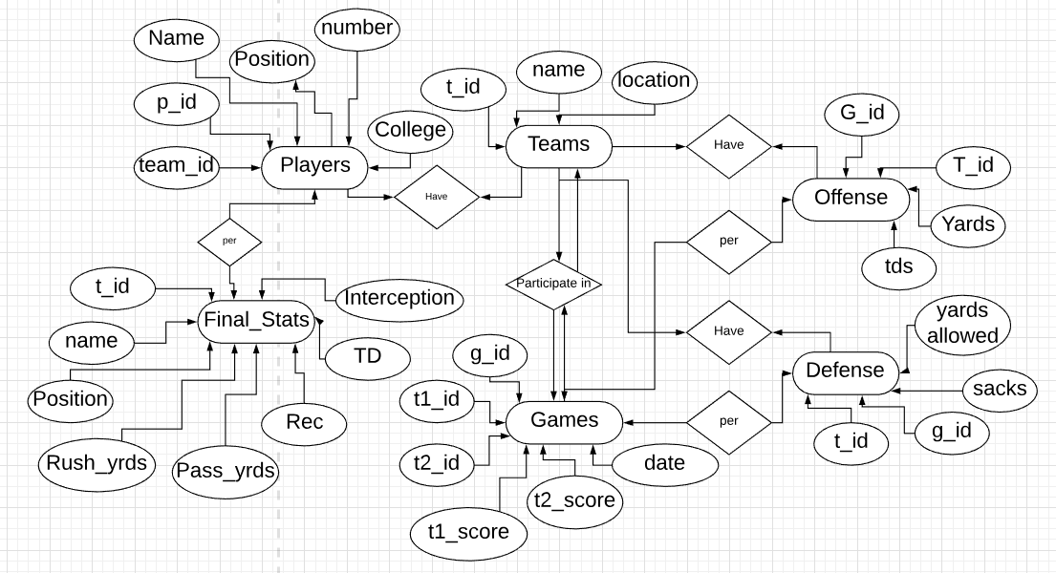

**Important Entities:**

We identified the important entities of our application as:

* **Teams**
* **Games**
* **Offense**
* **Defense**
* **Players**
* **Final_Stats**

**Attributes:**

From these important entities, we selected the following attributes to be stored in the database:

* Teams
  + **t_id**
  + **Name**
  + **Location**
* Games
  + **g_id**
  + **t1_id**
  + **t2_id**
  + **t1_score**
  + **t2_score**
  + **Date**
* Offense
  + **g_id**
  + **t_id**
  + **Yards**
  + **Tds**
* Defense
  + **t_id**
  + **g_id**
  + **Sacks**
  + **Yards allowed**
* **Players**
  + **Team_id**
  + **P_id**
  + **Name**
  + **Position**
  + **Number**
  + **College**
* **Final_Stats**
  + **T_id**
  + **Name**
  + **Position**
  + **Rush_yrds**
  + **Pass_Yards**
  + **Rec**
  + **TD**

**Constraints:**

* Teams, Games, Offense, Defense and Players each had primary keys which can’t be NULL
* T_id, t1_id, t2_id, g_id, t1_score, t2_score, yard, tds, sacks, yards allowed had to be integers
* Name, Location had to be string values

**Assumptions:**

# Part B - Database Design:

**Primary Key and Foreign Keys:**

The primary keys are as follows:

* Teams
  + **team_id**
* Games
  + **game_id**
* Offense
  + **g_id**
* Defense
  + **g_id**
* Players
  + **p_id**

The foreign keys are as follows:

* Teams
  + **team_id**
* Games
  + **team_id**
  + **Name**
* Offense
  + **g_id**
  + **t_id**
* Defense
  + **t_id**
  + **g_id**
* Players
  + **p_id**

# Part C - Database Creation and Interaction:

**Database Creation:**

* Data was gathered from:
  + <https://www.footballdb.com/>
  + <http://www.nfl.com/stats/player>
* The comma separated values were then loaded into the database to be interacted with via MySQL queries.

**Original Tables:**

**Players Table**

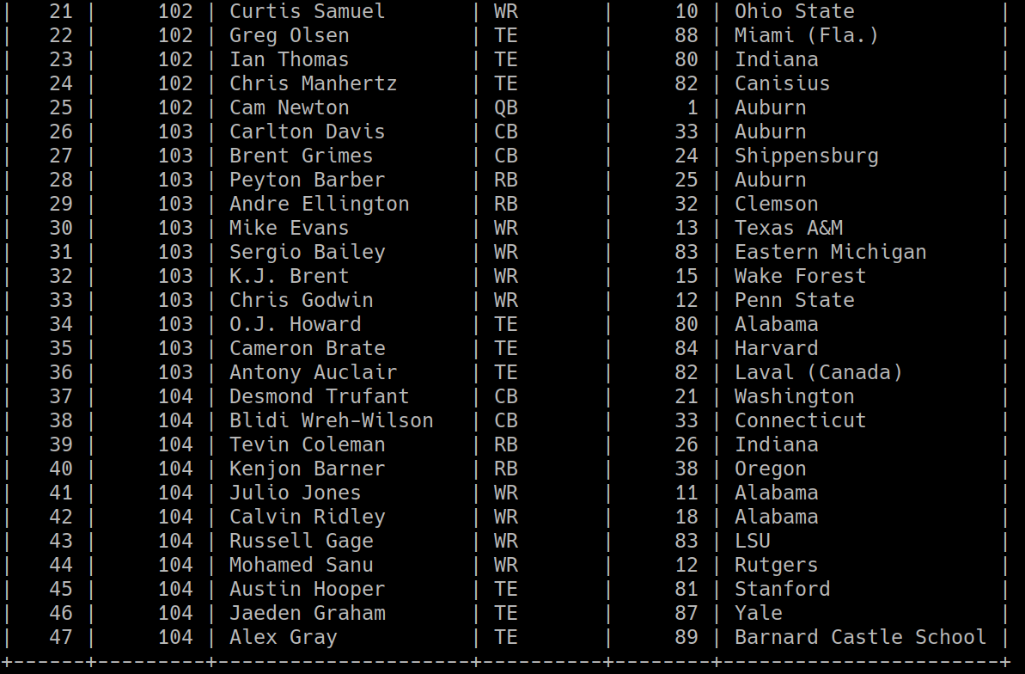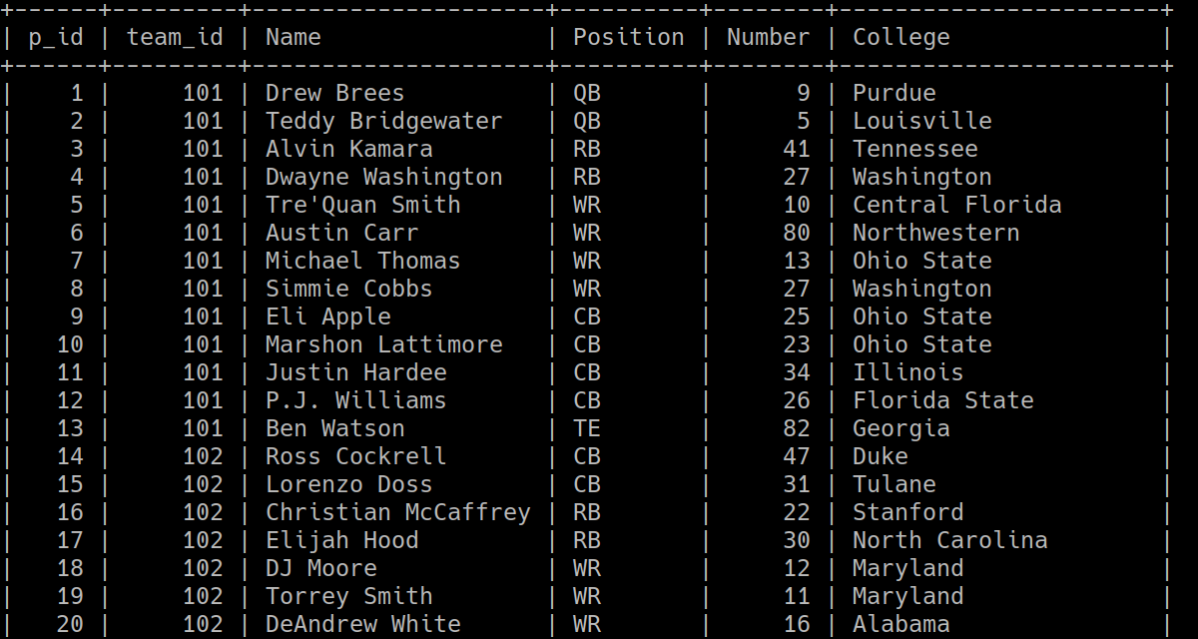

**teams table**

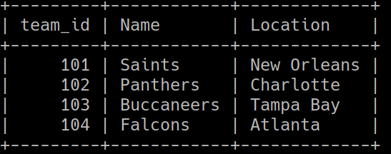

**Final_Stats table**

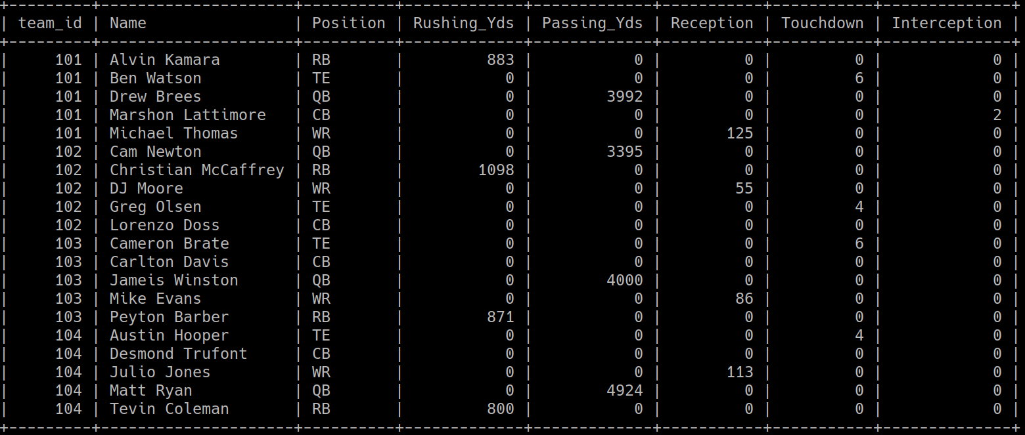

**Offense table**

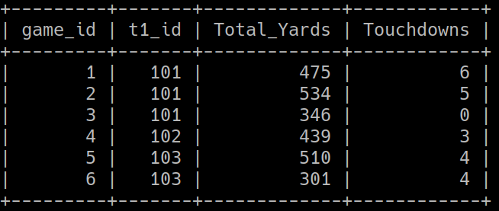

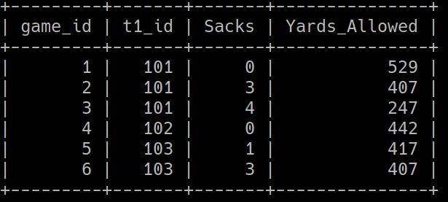**defense table**

**Queries:**

* Show a team from the final stats table (saints used in the example)
  + 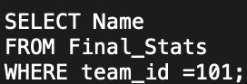
* Show average number of touchdowns from a team (saints used in the example)
  + Demonstration of use of aggregate function
  + 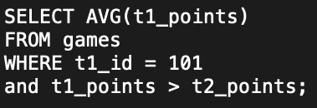
* Show offense and defense
  + Demonstration of Natural Join
* Find team_id of team that they beat
  + 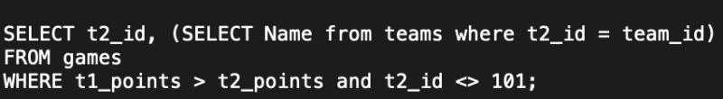
* Show wide receivers in descending order of receptions
  + Demonstrates ORDER BY
  + 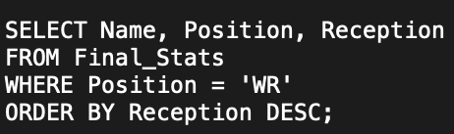
* Show all yardage covered by offense and defense
  + Demonstration of UNION ALL
  + 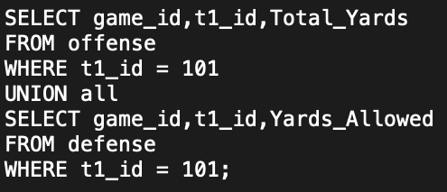
* Update passing yards for a team in the final stats
  + 